Instructions to take the online umpire quiz

Go to the following link: http://quizstar.4teachers.org/

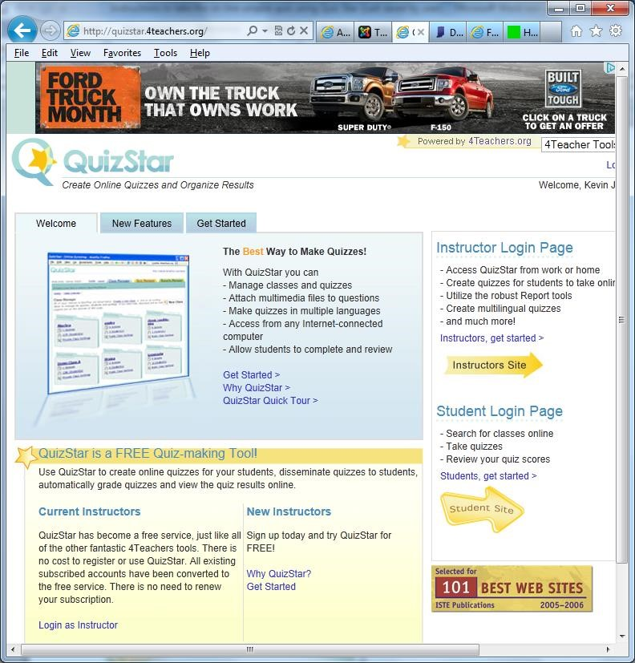

On the right side, click on “Student Site”.

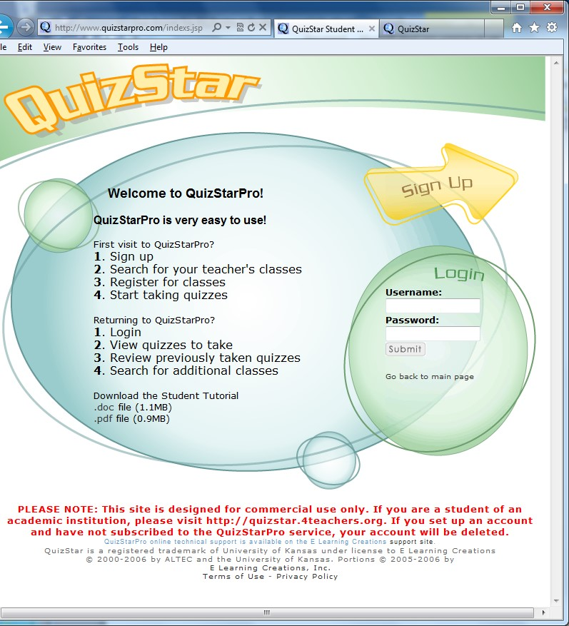

Click on “Sign Up”:

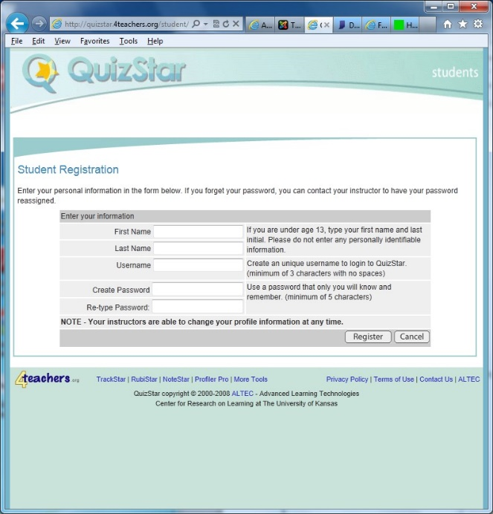

Fill in your first name, last name, create a user name, and enter a password 2 times. Click “Register”

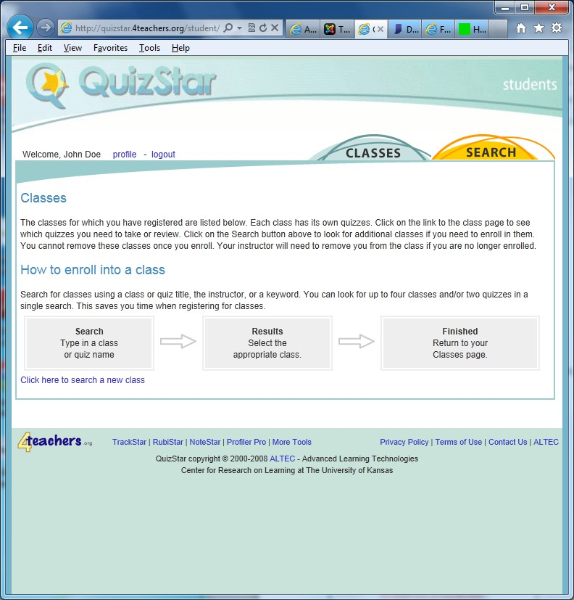

Click on the “Search” tab:

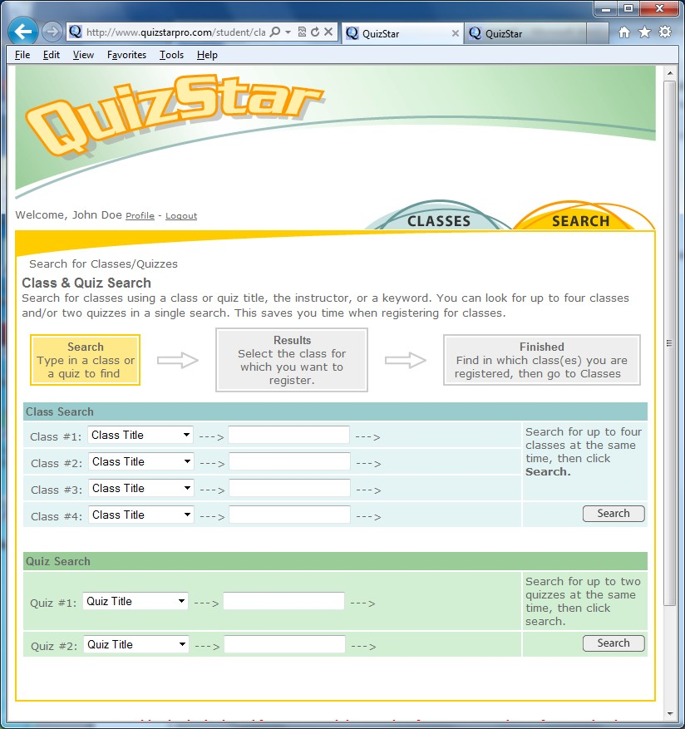

Under the Class Search section and to the right of “Class Title” type in “2024 OYO Umpires” and click “Exact Match”

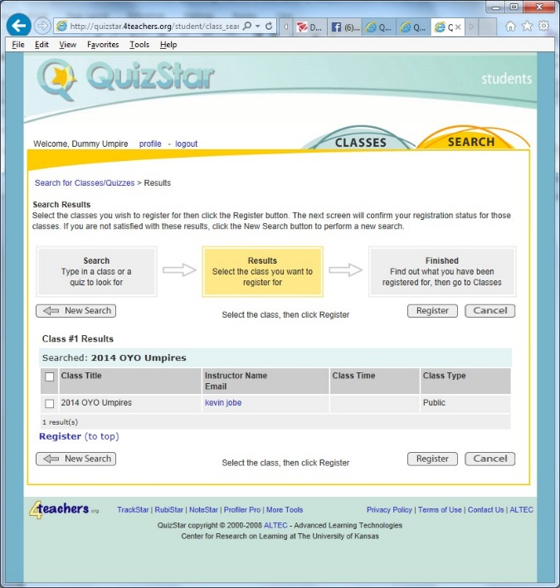

Check the “2024 OYO Umpires” check box and click “Register”.

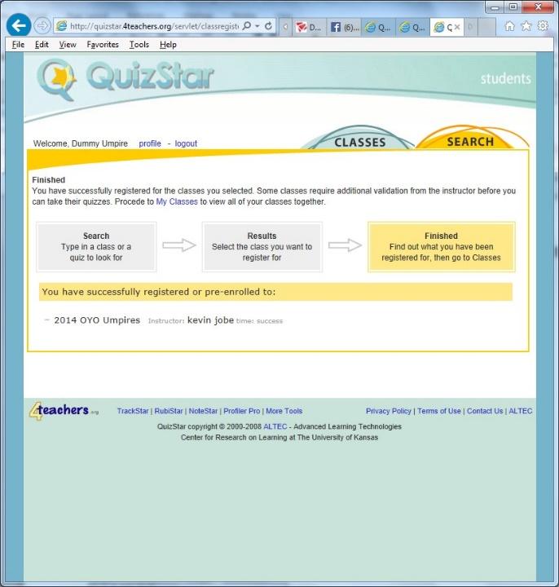

Click on the “Classes” tab:

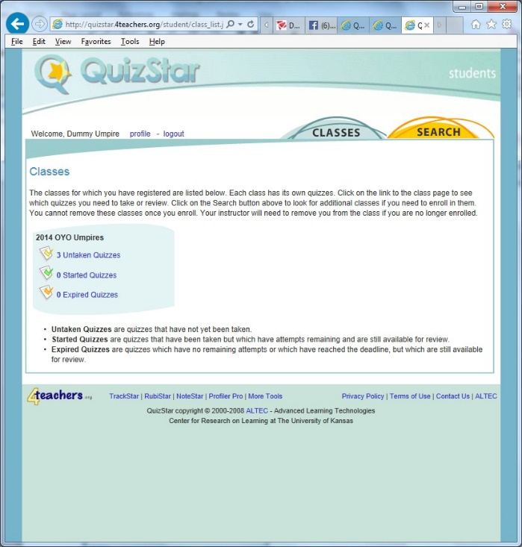

Click on “3 untaken quizzes” (Note it says 2022. Do not worry about it I could not figure out how to change the title.)

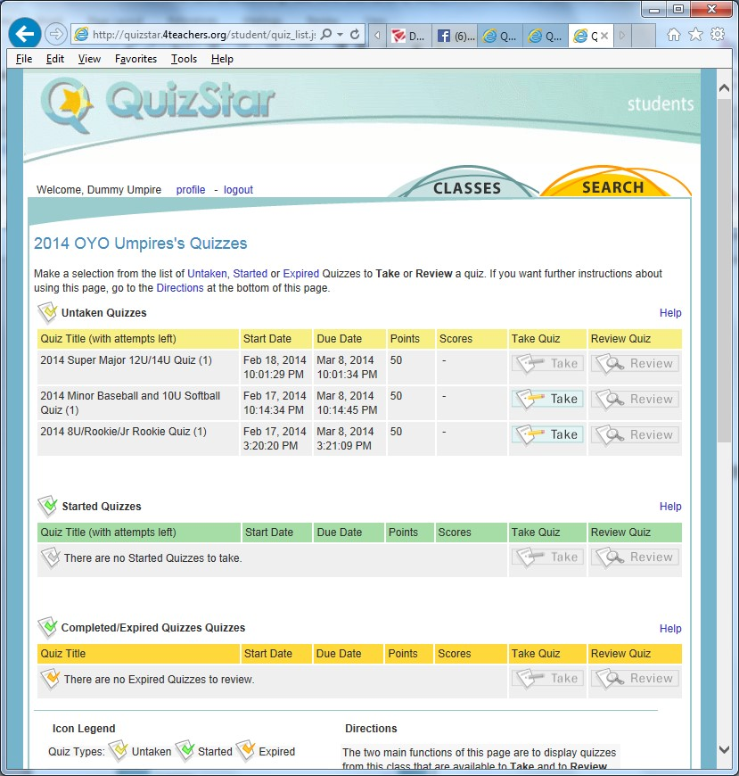

Select the appropriate quiz for your age group, and click “Take”

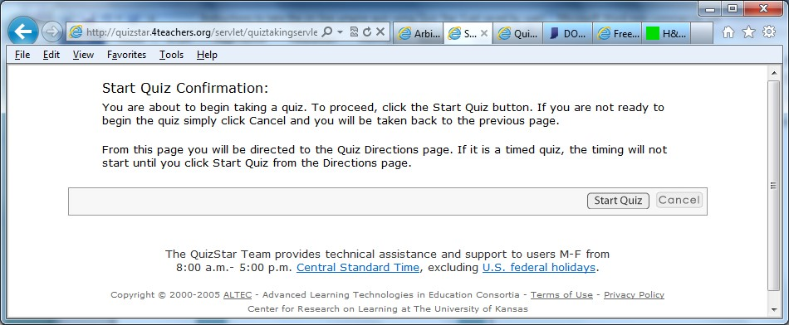

Click on the “Take” to start taking the quiz.

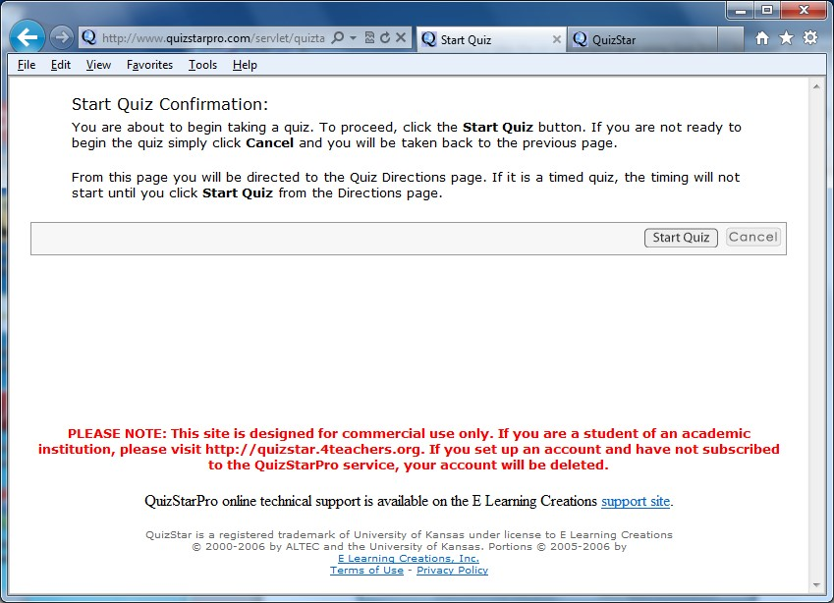

Click on “Start Quiz”

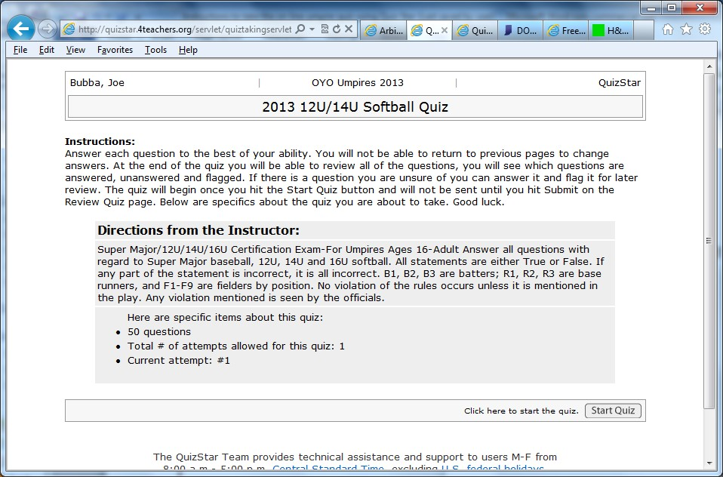

Click “Start Quiz” again

Once you start taking the quiz, you have 1 shot at it. You cannot stop it and restart it.

If you need me to reset your quiz, you will have to email me at atdesanto3956@gmail.com and request this or please text Anthony at 317-922-3956.

